Xcrox Testing Report
URL: https://xcros.in/beta

- Responsive Testing
Working Correctly
- Laptop L (1440px)
- iPhone XR
- iPhone 12 Pro
- iPhone 14 Pro Max
- Pixel 7
- Samsung Galaxy S20 Ultra
- iPad Air
- iPad Pro
- Surface Pro 7
- Galaxy Z Fold 5
- Asus Zenbook Fold
- Samsung Galaxy A51/71
- Nest Hub
- Nest Hub Max
Not Working Properly
- Mobile S (320px) – Upper and right-side content cut off, no side scrolling
- Mobile M (375px) – Upper content cut off
- Mobile L (425px) – Upper content cut off
- Tablet (768px) – Upper content hidden till timer bar
- Laptop (1024px) – Upper content hidden
- 4K (2560px) – Content appears too small
- iPhone SE – Upper content partially hidden
- Samsung Galaxy S8+ – Upper content slightly hidden
- iPad Mini – Upper content slightly hidden
- Surface Duo – Upper content hidden

- Xcrox Beta Version Functional Testing Report:
Working Properly
- Navigation between pages is working correctly
- QR code scanning is functioning properly
Issues Found
- QR code redirects to a page showing “Deactivated” instead of the app download page
- “Chat with Admin” feature is not working properly
Buttons/Sections Not Working
- Set Up Notifications
- Submit a Ticket
- Knowledge Base
- Video Tutorials
- Reviews
- Forum
- Webinars
- ChatGPT
- AI
- Whiteboard

- Beta Version Legal & Terms Testing Report
Contact Us – User Legal Section
Issues Found
- Website Terms and Conditions page is displaying raw HTML code
- Web links are not rendering properly as clickable formatted content
- HTML tags are visible directly on the page
- Page formatting and readability are affected

Website Terms and Conditions
Code Display Issue
- Corporate and Project links are showing source code instead of formatted text
- Incorrect rendering of anchor tags and styling elements
- Content appears broken and unstructured on the page

- Manage Consent Preferences – Cookies Section
Issues Found
- Cookie preference options are displayed incorrectly
- “Radio active button” text is shown instead of proper toggle/radio buttons
- Functional option is not rendering correctly
- Performance and Analytics option is not rendering correctly
- Targeting option is not rendering correctly
- Consent UI appears broken and non-interactive
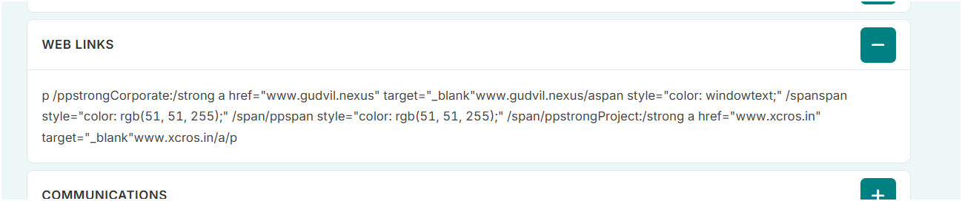

Xcrox Beta Version City-wise Testing Report
Bangalore
- City page is working properly
- Images and content are loading correctly
Chennai
- Certain images are not loading properly
- Main Launch Sponsor popup contact option is not working
- In Launch Sponsor section, only two images are visible
- Remaining sponsor images are not displaying properly

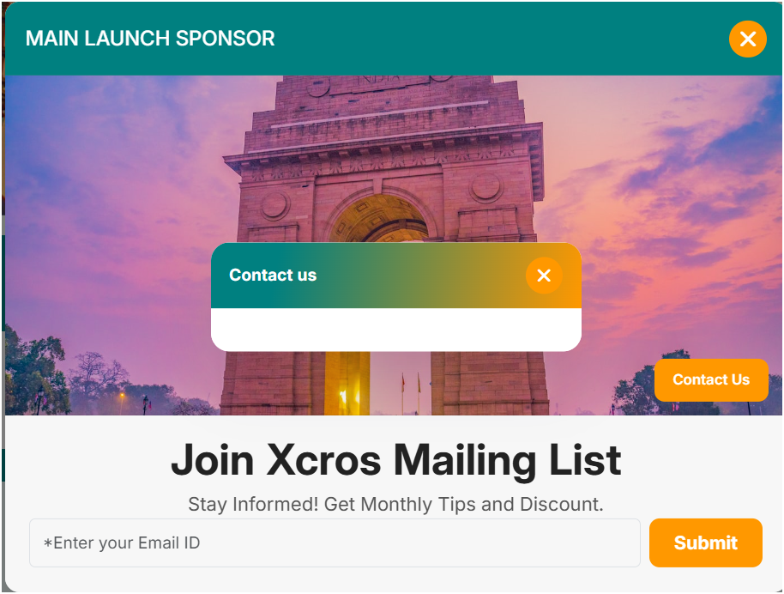

- Beta Version Feature Listings Test Report
View All Pincodes Section and view cities:
Observed Issues
- A few images are not loading correctly in the “View All Pincodes” page.

Featured Listings – Business
Observed Issues
- Multiple images are missing or not visible properly.
- Some “Sort By” filter options are not responding correctly.
- “Grand Spice Kitchen” image is not loading.

Featured Listings – Professionals
Observed Issues
- Certain images are not displayed properly.
- “Book an Appointment” option is not functioning.
- “Grand Spice Kitchen” image is missing.

Featured Listings – Handyman
Observed Issues
- “Book an Appointment” redirects to the wrong page.
- “Grand Spice Kitchen” image is not visible.

Explore Popular Categories
Categories Checked
- Women’s Fashion
- Sports and Outdoors
- Real Estate
- Jewellery
- Home and Garden
Observed Issues
- “Grand Spice Kitchen” image is not displaying in the listed categories.
- Beta Version Jingle Testing Report
Areas Tested
- Promoted Listings inside each category
- Restaurant detail pages
Issues Identified
- The jingle/audio feature is not working in the promoted listings section.
- Jingle playback is not functioning on restaurant pages across different categories.
- Audio controls are either unresponsive or not triggering playback properly.
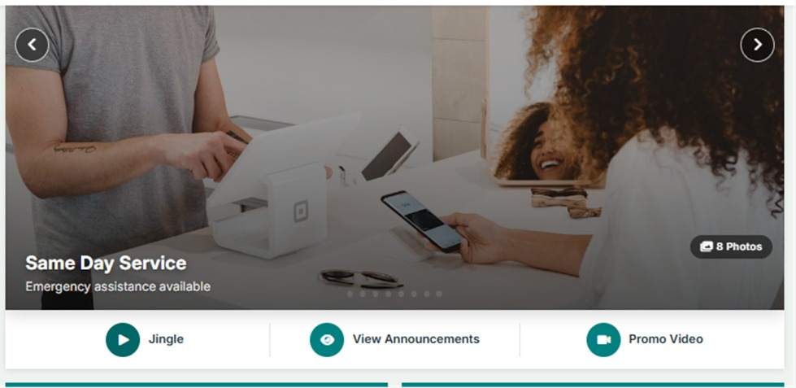

Promoted Categories
Observed Issues
- “Grand Spice Kitchen” image is not loading properly in the promoted category section.

- Support – Help Center Testing Report
View by Connect Through Pincode
Issues Identified
- While clicking the “Vertical Market” button, it is navigating to the “Choose Service” page instead of the intended “Vertical Markets” page.
- Incorrect page redirection is occurring for the Vertical Market navigation option.

Gallery Section
Issues Identified
- The “Add” button is not functioning properly.
- Images are not displaying correctly in the Gallery section.
- Gallery content loading requires fixes.

Help Line Section
Issues Identified
- The “Get Directions” button is not working.
- Navigation/redirection for directions is not functioning properly.
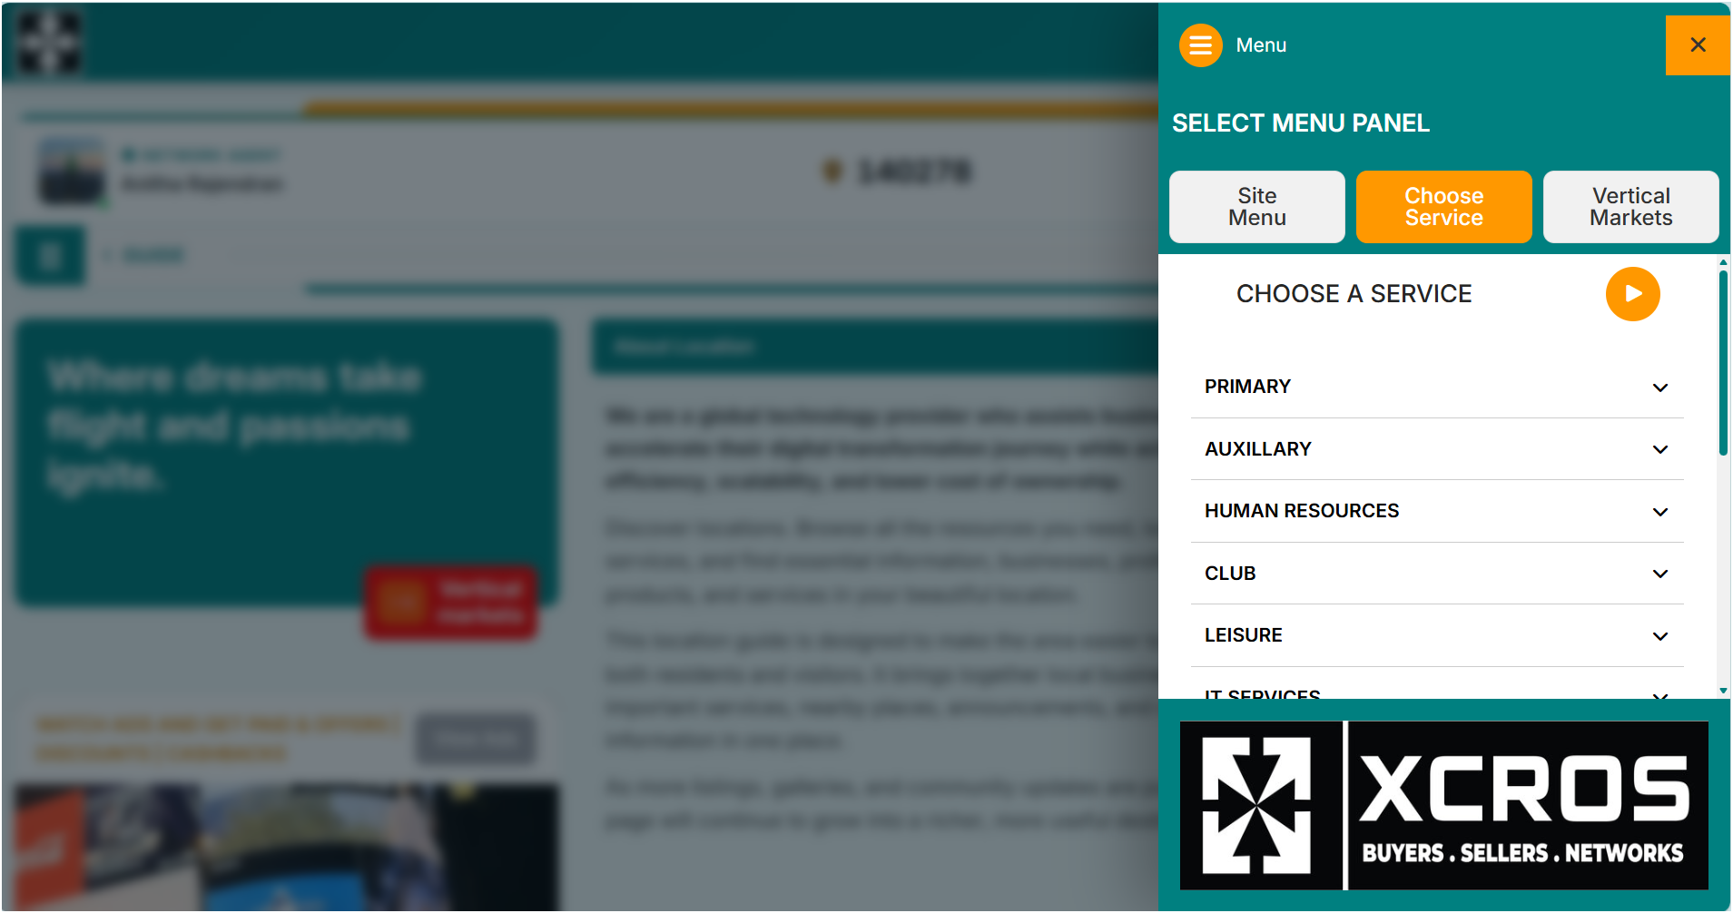

- Support – Help Support Testing Report
Menu Bar → Support → Help Support → View Profile
Reviews and Services Agents Section
Issues Identified
- Images in the Reviews section are not displaying properly.
- Service agent images are missing or not loading correctly.
- Some profile image placeholders appear blank.

Advertisements Section
Issues Identified
- Advertisement carousel is not functioning properly.
- Carousel sliding/navigation is not working.
- Advertisement content is not rotating automatically.

- Support – Help Center Service Marketplace Testing Report
Menu Bar → Support → Help Center → Service Marketplace
Search Settings Section
Issues Identified
- Search settings dropdown is not functioning properly.
- Dropdown options are not opening when clicked.
- Users are unable to select or modify search settings.

- Support – Help Center Service Marketplace Stores Testing Report
Menu Bar → Support → Help Center → Service Marketplace → Stores
Filter Section
Issues Identified
- Price range filter is not functioning properly.
- Users are unable to adjust or apply the price filter.
- Filtering results based on price range is not working.

Advertisements Section
Issues Identified
- Advertisement images are not displaying properly.
- Some advertisement sections appear blank due to missing images.
- Image loading issue affects the visual layout of the page.

- About Section Testing Report
Menu → About → Careers
Issues Identified
- “Explore Opportunities” button is not navigating properly.
- No page redirection occurs after clicking the button.
- Career opportunities section is inaccessible due to navigation failure.

Gudvil-Nexus Section
Issues Identified
- “Services” option is not functioning properly.
- Clicking the Services link does not navigate to the intended page.
- Service-related content is inaccessible.

Get Social Section
Issues Identified
- “Get Social” page appears blank.
- No content is loading inside the section.
- Page rendering issue affects usability.

- Vertical Markets – Expo Testing Report
Menu Bar → Vertical Markets → Expo
Issues Identified
- “Expo Calendar” button is not functioning properly.
- Clicking the button does not navigate to the intended calendar page.
- Expo schedule/calendar information is inaccessible due to navigation failure.
Conclusion
- The testing of the Xcrox Beta Version identified multiple issues related to responsiveness, navigation, image loading, button functionality, dropdowns, filters, and page rendering across different sections of the website.
- Several features and pages were working correctly on multiple devices, but some sections contained broken links, missing images, non-functional buttons, incorrect redirections, and UI display issues.
- The prepared testing reports will help the development team identify and fix the detected issues to improve the overall functionality and user experience of the platform.

